**Computational Linguistics & NLP Lab 2**

**Implementing:**

* **Tokenization**
* **Stemming**
* **Lemmatization**
* **Stop word removal**

**Code:**

import nltk

from nltk.tokenize import word_tokenize

from nltk.stem import PorterStemmer, WordNetLemmatizer

from nltk.corpus import stopwords

from nltk import pos_tag

nltk.download('punkt')

nltk.download('stopwords')

nltk.download('wordnet')

nltk.download('averaged_perceptron_tagger')

**Output:**

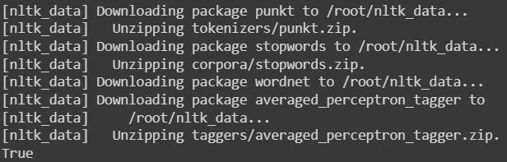

def preprocess_text(text):

    # Tokenization

    tokens = word_tokenize(text.lower())  # Convert to lowercase for consistency

    # Removing stopwords

    stop_words = set(stopwords.words('english'))

    tokens = [token for token in tokens if token not in stop_words]

    # Stemming

    stemmer = PorterStemmer()

    stemmed_tokens = [stemmer.stem(token) for token in tokens]

    # Lemmatization

    lemmatizer = WordNetLemmatizer()

    lemmatized_tokens = [lemmatizer.lemmatize(token) for token in tokens]

    return tokens, stemmed_tokens, lemmatized_tokens

input_text = "Tokenization is an important step in natural language processing. It involves stemming and lemmatization."

tokens, stemmed_tokens, lemmatized_tokens = preprocess_text(input_text)

print("Original Tokens:", tokens)

print("Stemmed Tokens:", stemmed_tokens)

print("Lemmatized Tokens:", lemmatized_tokens)

**Output:**



def pos_tagging(text):

    tokens = word_tokenize(text)

    pos_tags = pos_tag(tokens)

    return pos_tags

tags = pos_tagging(input_text)

print("POS Tags:", tags)

**Output:**

